Weekly Report

On

“HEALTHCARE”

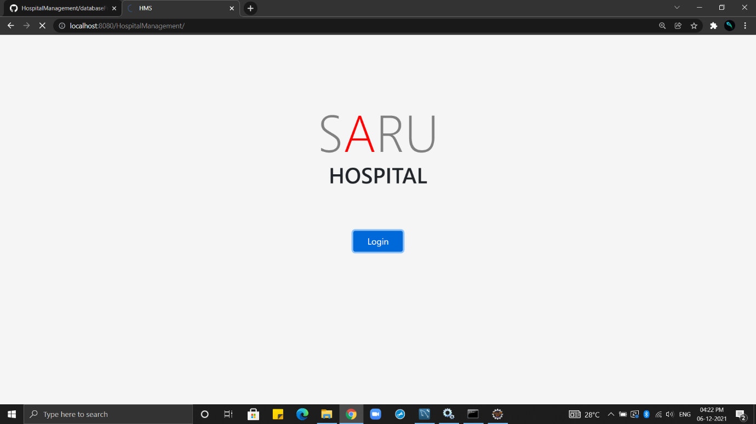

Prepared

By

Sandeep kodari

(STU61b4d3d9ecaa81639240665)

Department of Computer Science Engineering

Vardhaman college of engineering

JNTU –HYDERABAD

**Week 1**

**Problem Statement:**

Health Care Guidance system is an organized computerized system designed and programmed to deal with day-to-day operations and management of the hospital activities. The program can look after inpatients, outpatients, records, database treatments, status illness, billings in the pharmacy and labs. It also maintains hospital information such as ward id, doctors in charge and department administering. The major problem for the patient nowadays to get report after consultation, many hospital managing reports in their system but it's not available to the patient when he / she is outside. In this project we are going to provide the extra facility to store the report in the database and make available from anywhere in the world.

**Background of the Problem:**

The main objective of the project is to hail a fully computerized system for main fining patient detail, patient bills, and ward details**.**

**User / Customer:**

Primary actor: Patient

Secondary actor: doctors, Admin

**Week 2**

**Proposed Solution:**

The proposed software product is the Hospital Management system (HMS). The system will be used in any hospital (only in OPD case), clinic etc.Hospitals (small to medium

scale) can used it to to get the information from the patients and then storing that data for

future usages. The intention of the system is to reduce over-time pay and increase the number

of patients that can be treated accurately. Requirement statements in these documents are

both functional and non-functional.

**1. Front end Technologies:**

* HTML
* CSS
* Bootstrap
* JavaScript

**2. Back end Technologies:**

* SpringMVC
* Hibernate

**Example of Existing Solution:**

**origamirisk-https:** //www.origamirisk.com/solutions/industry-healthcare?_bt=479817090218&_bk=healthcare%20management%20solutions&_bm=p&_bn=g&_bg=116810641321&gclid=CjwKCAiAjs2bBhACEiwALTBWZTgsFrEW73wSS_mKRJwr-ijDNsGVJyMXdhCoqJDVYRIFociFQgRwMxoC_k4QAvD_BwE

**Week 3**

**User Flow:**

**––**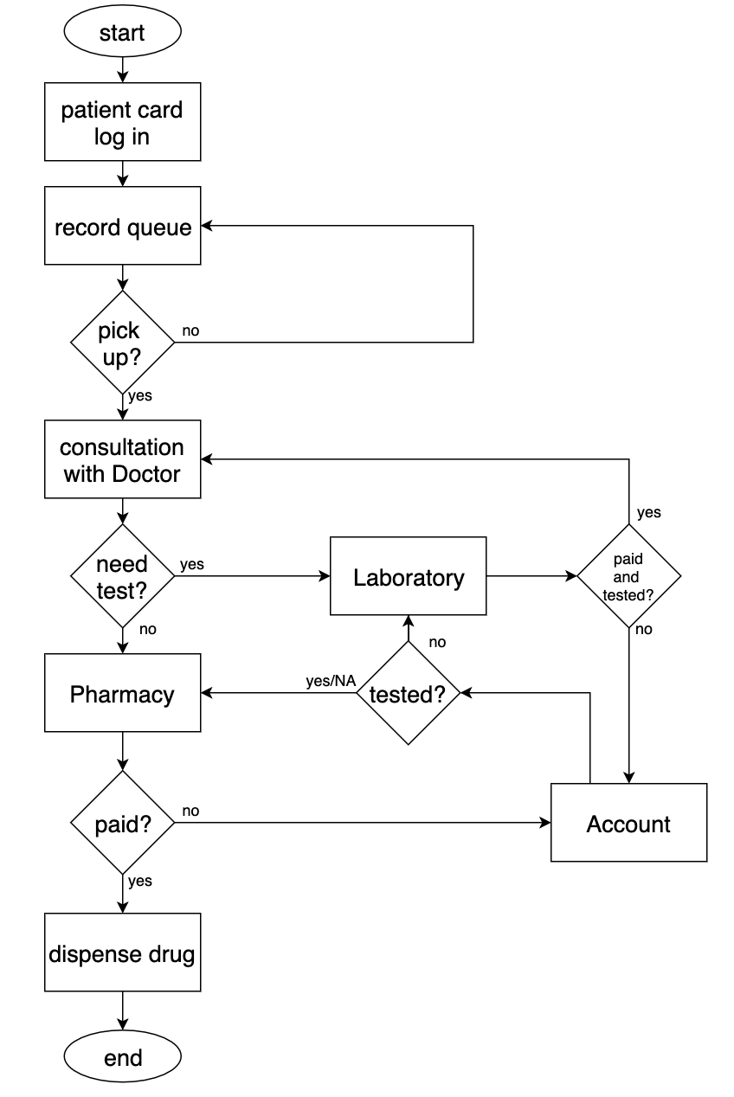

1. **Usecase Diagram[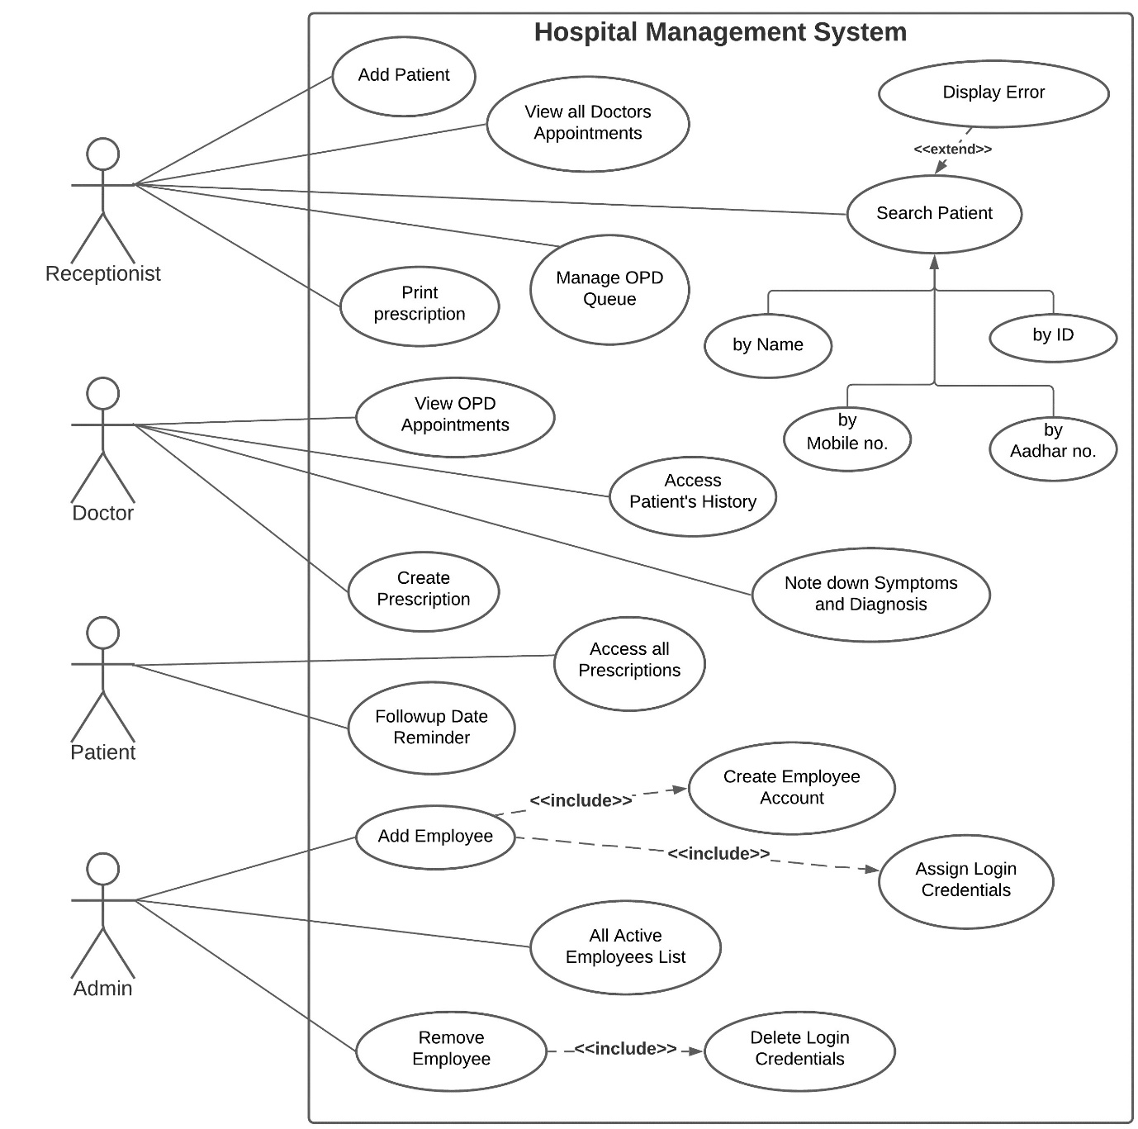](https://github.com/rid17pawar/HospitalManagement/blob/master/readme_images/System%20Diagrams/Usecase%20Diagram.jpg)**
2. **Activity Diagram**

**[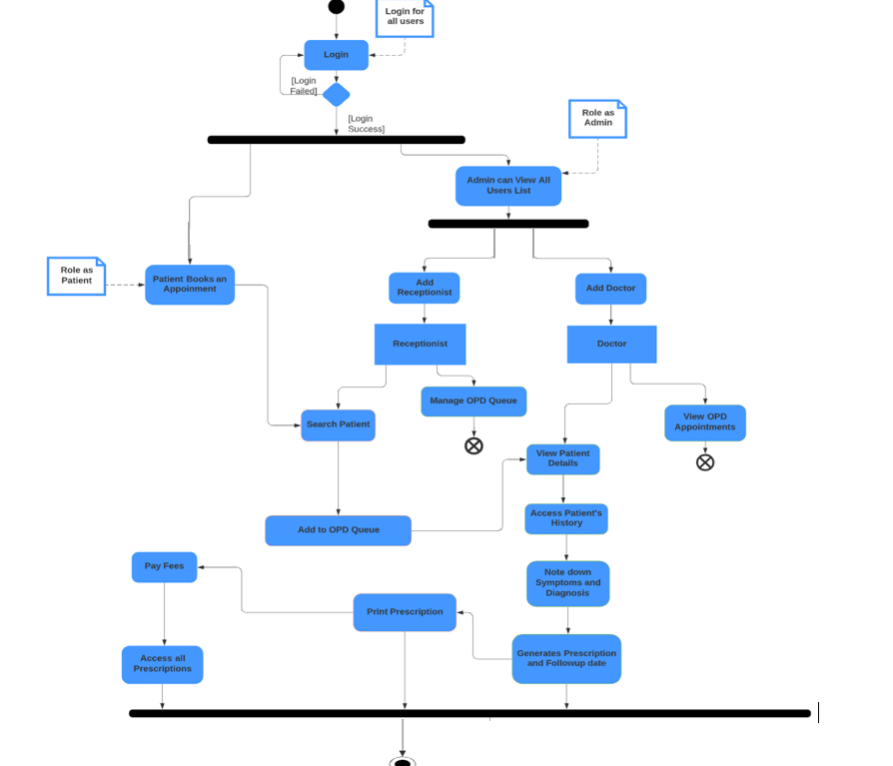](https://github.com/rid17pawar/HospitalManagement/blob/master/readme_images/System%20Diagrams/Activity%20Diagram.png)**

1. **Class Diagram**

**[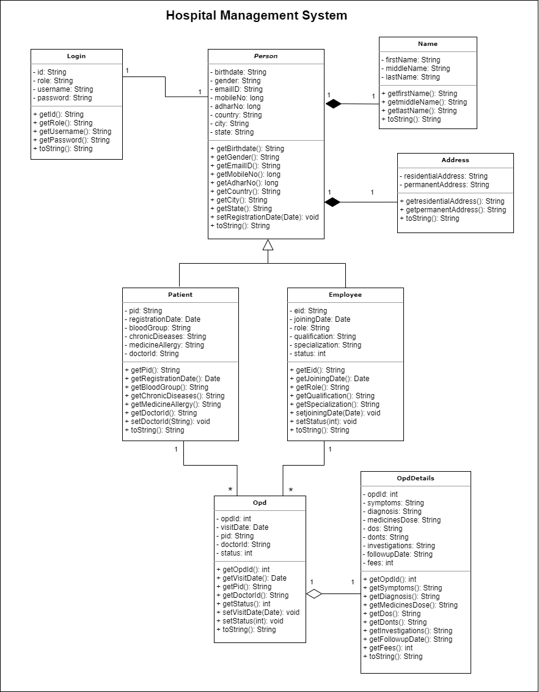](https://github.com/rid17pawar/HospitalManagement/blob/master/readme_images/System%20Diagrams/Class%20Diagram.png)**

1. **Sequence Diagram**

**[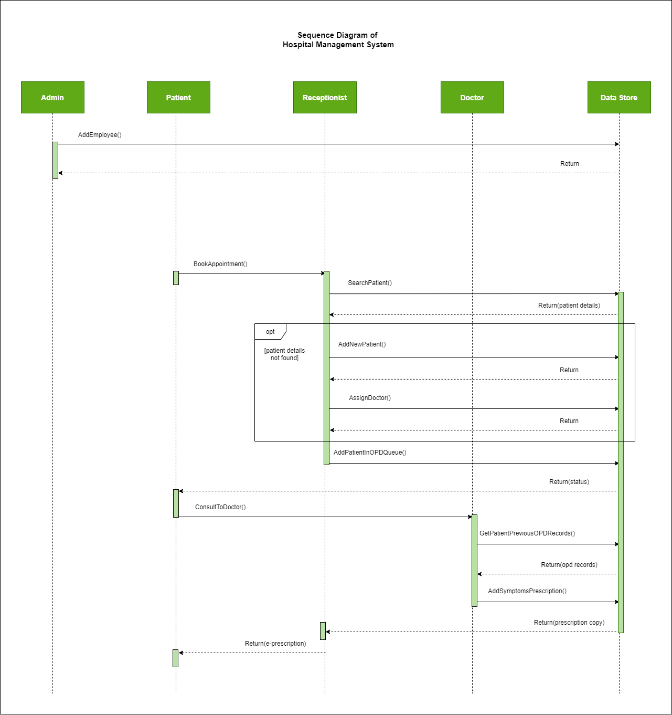](https://github.com/rid17pawar/HospitalManagement/blob/master/readme_images/System%20Diagrams/Sequence%20Diagram.png)**

1. **State Diagram**

**[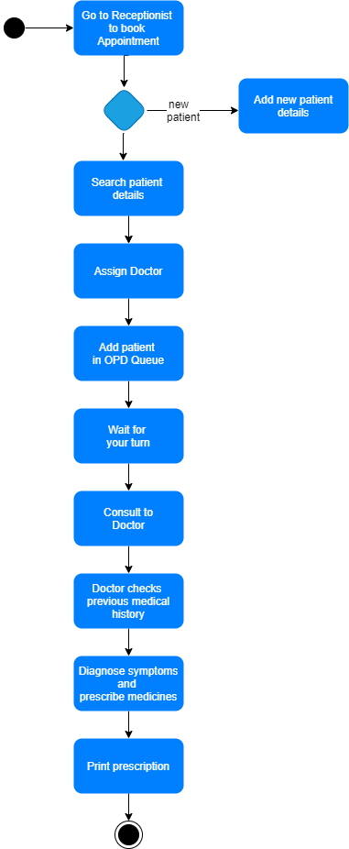](https://github.com/rid17pawar/HospitalManagement/blob/master/readme_images/System%20Diagrams/State%20Diagram.png)**

**Week 4**

**Link for the Website (Hosted on GitHub):**

[sandeep9515-2/aictb3_project (github.com)](https://github.com/sandeep9515-2/aictb3_project)